1. For **Step Definition** template for any feature file, we’re dependent on “Pretty Gherkin” but that is not the only way.
2. We have one more way.
   1. Let’s comment the code in StepDefinition.java.   
      Text

      Description automatically generated
   2. Run the Runner.   
      Graphical user interface, application

      Description automatically generated
   3. Template is generated.   
      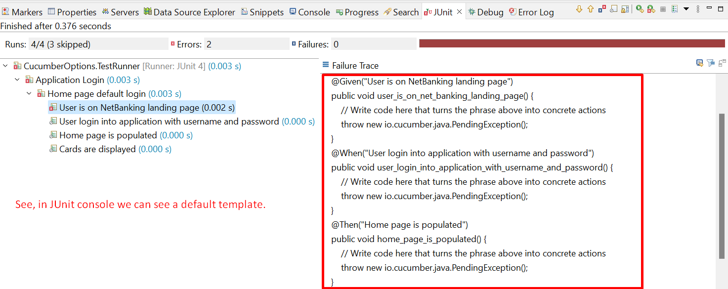
3. Let’s see how to write a common step definition (method in Step Definition File) for two or more steps (in feature file) which are same with different values.
   1. **Writing two steps having same plain English with different values.**
   2. Text

      Description automatically generated
   3. **Evaluating the step into Step Definition**.

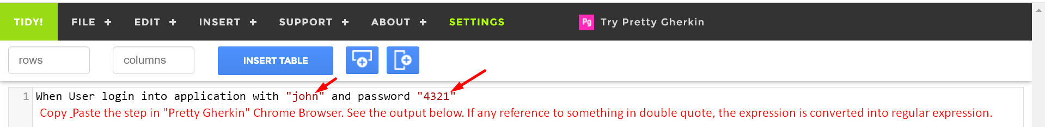  


* 1. **Running Test Cases**:  
     Graphical user interface, text, application, Word

     Description automatically generated